Create a table **student_data**with the following fields: roll  number(primary key), name, age, place.

a.       Create a **view**which contains only roll number and name.

b.      List the data of the view.

c.       Describe the view.

d.      Insert a value into the view and list the view and table.

e.       Update a value in the view and list the view and table.

f.        Delete a value in the table and list the view and table.

g.      Create another view which contains name and age column and check whether the above operations are possible in this view.

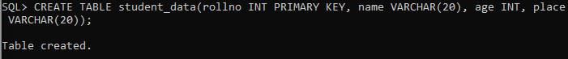

**Answers:**







